Project Development Phase
Model Performance Test

Date | 3 OCTOBER 2026
Team ID | SWTID-2026-9505
Project Name | Project - Implement Client Script & UI Policy (Incident) in ServiceNow
Maximum Marks

Model Performance Testing:
Project team shall fill the following information in model performance testing template.
S.No. | Parameter | Values | Screenshot
 | Model Summary | ServiceNow configuration to control Incident form behaviour using a UI Policy (High Impact Control) and Client Scripts (onChange, onSubmit and onCellEdit).  Note : When Impact is High, Urgency is set to 1 - High automatically; invalid saves and direct list edits of the State field are blocked with a message. | 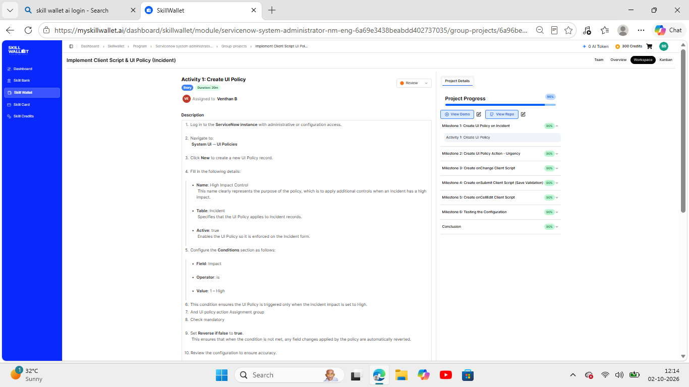
 | Accuracy | Not applicable - this is a ServiceNow configuration project and does not use a trained ML model.  Testing result: all 5 test activities in Milestone 6 (mandatory enforcement, successful save, reverse condition, list edit blocking, form-based update) behaved as expected. | - 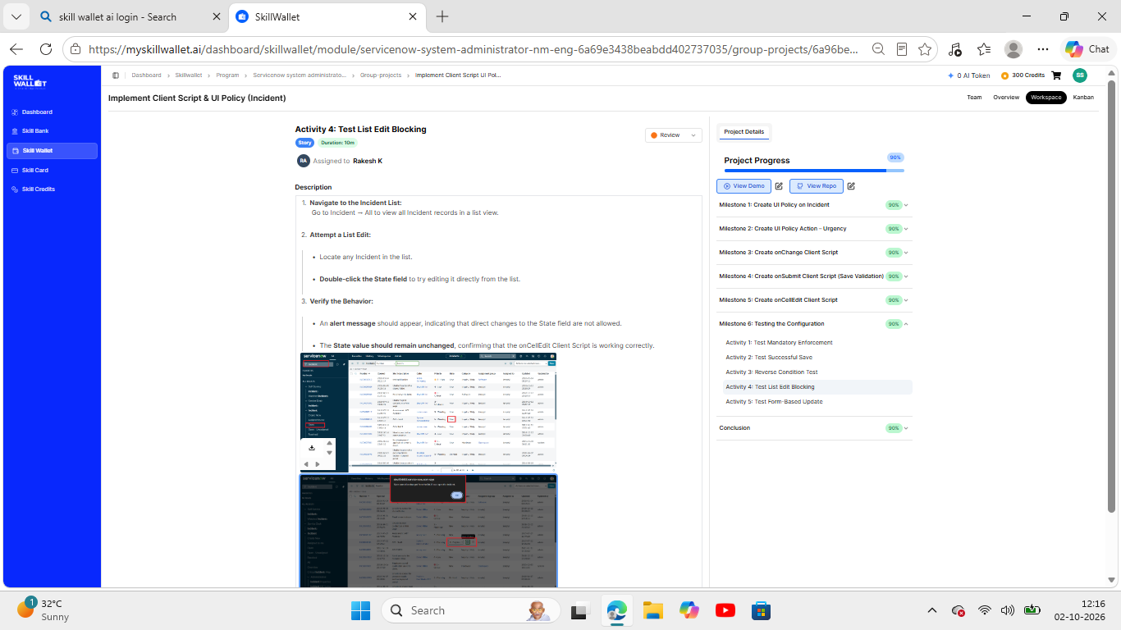
3. | Confidence Score (Only Yolo Projects) | Not applicable - confidence score is only for YOLO projects. Screenshots show the onChange and onCellEdit client scripts used.  Class detection / confidence score: N/A | 